Group 1

**Team members:**

Lauren Adams, Harmond Drenth, Yangzekun Gao, Ryan Huntington, Anshpreet Kaur, Ruiqi Zhao

**Group name: “**Subject to Change”

Each member's role assignment.:

*Team leader*: Ryan Huntington

*Requirements Enginee*r: Lauren Adams

*Design Engineer*: Ruiqi Zhao

*Quality Assurance*: Yangzekun Gao

*Project Librarian*: Anshpreet Kaur

*Devops Engineer*: Harmond Drenth

- Project Manager will be responsible for coordinating the activities of the group and for liaison with the instructor to resolve issue affecting the group from time to time. The project manager should be: professional and responsible, a good organizer and an effective communicator.

- Requirements Engineer leads the requirements effort.

- Design Engineer leads the design effort.

- Quality Assurance Engineer oversees test case design, validation of requirements, design, etc.

- Project Librarian keeps all meeting logs and makes all design artifacts available for the team.

**Group communication logistics**

* Meet in person every Monday around our mentor time-slot.
* Discord group for virtual meetings at weekends
* GitLab for code sharing

Use Case Diagram: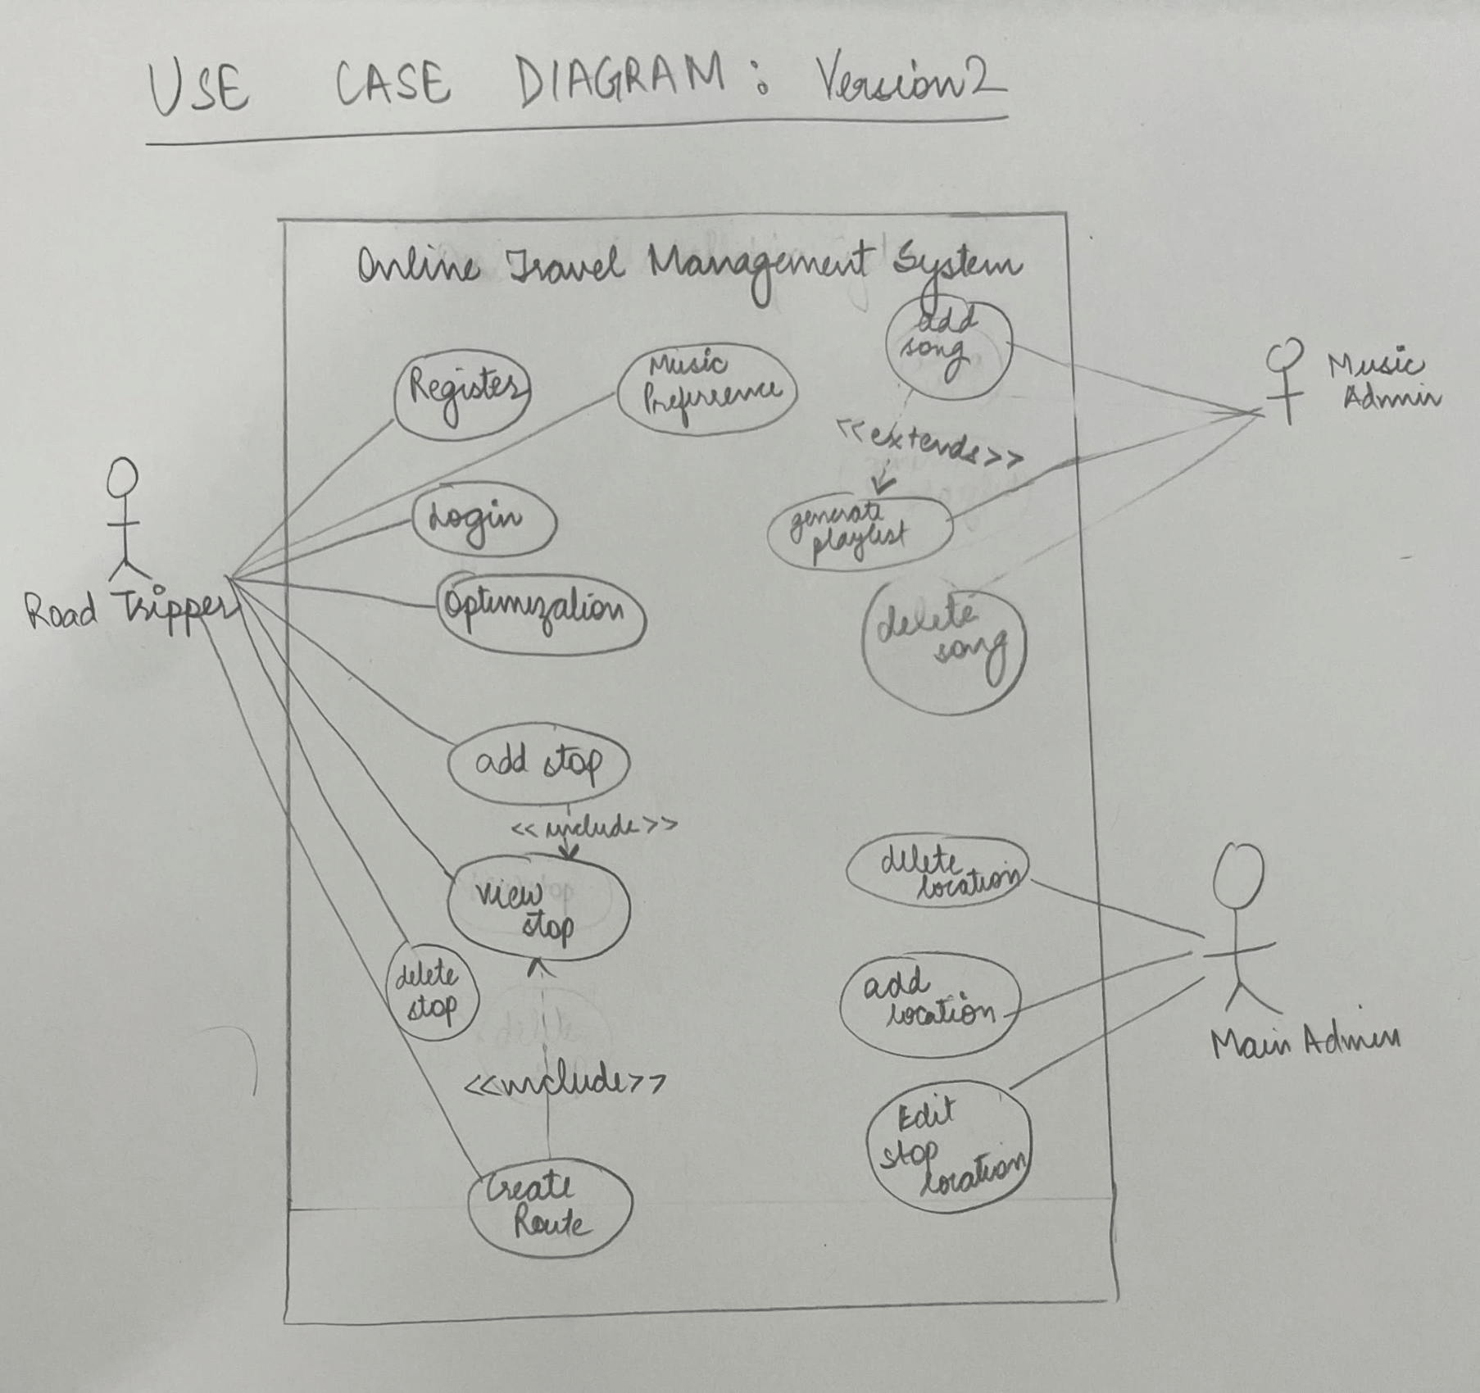

**6 use cases:**

1. Log in/ registration  
     
   **Brief UC:**  
   If the user has a created account and the web page is not logged in, then the user will be able to log in with his/her created account. The user has to finish the login process by entering the correct username and password.

______________________________________________________________________________________________

**Casual UC:**  
  
**Main success Scenario:**   
When the user is in guest mode, the user can choose to log in. When logging in the user is prompted for a username and password. When the user enters the correct username and password, the user will successfully log in as either customer or owner depending on the type of account.   
  
**Alternate Scenario:**   
When the user enters an incorrect username or password, an error message will display indicating that the user cannot log in. The system will then allow the user to enter their credentials again.

______________________________________________________________________________________________

**Fully Dressed Use Case**  
**Use case:** Log in  
  
**Scope:** account management system   
  
**Actor:** owners, customers Level: user goal   
**Brief:** If the user has a created account and the web page is not logged in, then the user will be able to log in with his/her created account. The user has to finish the login process by entering the correct username and password.   
  
**Preconditions:**   
1. The user is not logged in yet.   
2. The user has at least one account.   
3. The user wants to log in.   
  
**Postconditions**:   
1. The user successfully logged in.   
  
**Basic flows:**   
1. Selecting the role of the account(owner/customer)   
2. Entering the username.   
3. Entering the password.   
4. Direct to the user’s main page(profile).

______________________________________________________________________________________________

## Delete Stop

**Brief UC**

The owner deletes the stop that he wants to delete and the updated path is given to the user.

______________________________________________________________________________________________

**Casual UC**

If the user is already logged in and has a road trip with at least one stop then The user views the stops and deletes the one he wishes to delete

If the user is logged in and has a trip planned with no stop, he would have no stops in the list and thus would not be able to delete anything and he would be brought back to the home screen.

______________________________________________________________________________________________

**Fully Dressed Use Case**

**ID:** UC 02

**Title:** Delete Stops

**Description:**

The owner deletes stops for his route

**Primary Actor:**

Road Tripper

**Precondition:**

The user is logged in and has a trip already planned with at least one stop.

**Post-condition:**

The stop is deleted and the route for the road tripper is updated

**Main Flow:**

* The user clicks on view trip.
* The user selects the desired stop that he wishes to delete
* The user clicks on delete option
* The user confirms the delete

**Frequency of Use:**

Frequently Used

**Status:**

In progress

**Owner:**

Anshpreet Kaur

______________________________________________________________________________________________

1. Changing Fun Level

**Fully Dressed Use Case**

**ID:** UC 03

**Title:** Change Efficiency

**Description:**

The Road-tripper should be able to switch the focus of the route between levels of fun and efficiency.

**Primary Actor:**

Road-tripper

**Precondition:**

* The road-tripper has a registered account
* The starting position exists is in database
* The use has a desire to select a level of efficiency
* Levels of efficiency are pre-established and calculatable based on the route
* The ending position is in the database

**Post-condition:**

* A route is presented to the road-tripper to get from the starting point to the ending point with a desirable level of fun.
* The selected level of efficiency should correspond to the amount of stops and distance of deviated time from the optimal route.

**Main Flow:**

1. Road-tripper starts a new road-trip

2. Enters start

3. Enters end

4. Determines fun to efficiency ratio

5. Road-tripper starts road-trip

6. Road trip is calculated with appropriate efficiency

**Frequency of Use:**

Very frequent as all created routes will have this functionality selected

**Status:**

In Progress

**Owner:**

Lauren Adams

**Priority:**

Medium

______________________________________________________________________________________________

**Brief UC**

Change Efficiency – When using the application, a user should be able to create a route to determine a path to get from a starting position to an ending position. The road-tripper should be able to determine the fun to efficiency ratio with frequent stops at attractions, or the quickest path possible on a set scale. After inputting their information, our system should be able to develop a path best suited to their desires.

______________________________________________________________________________________________

**Casual UC:**

When the user decides it is time to create a new route, the user can select the “Start new Road-trip”. After selecting this option, the road-tripper is taken to a new page where they will be prompted to enter various types of information, such as starting position, ending position, an option for additional stops, and the efficiency to fun ratio. The efficiency to fun ratio has 5 levels from most efficient to most fun. The most efficient will be based solely of travel route speed and the most fun will have as many stops as possible while still getting to end location within a set amount of variable time. At any point in this process, the road-tripper will be able to leave and cancel the road-trip. After filling in the required information, the starting and ending locations, the road-tripper will be able to select “Start trip” or cancel. A route will be generated and then shown to the user.

1. Create route

**Brief UC:**

Create Route – When using the application, a user should be able to create a route to determine a path to get from a starting position to an ending position. The road-tripper should be able to input a starting position, ending position, any additional stops they may want along the way, as the option to determine the fun to efficiency ratio with frequent stops at attractions, or the quickest path possible. After inputting their information, our system should be able to develop a path best suited to their desires.

______________________________________________________________________________________________

**Casual UC:**

When the user decides it is time to create a new route, the user can select the “Start new Road-trip”. After selecting this option, the road-tripper is taken to a new page where they will be prompted to enter various types of information, such as starting position, ending position, an option for additional stops, and the efficiency to fun ratio. At any point in this process, the roadtripper will be able to leave and cancel the road-trip. The road-tripper will be able to select various locations from our database for the starting, ending, and additional stops, or input their own locations that they wish. If they have difficulty finding locations, they will also be able to search for the various locations within our database. When determining the fun to efficiency ratio, they will be able to determine if they want the fastest route, or would prefer frequent stops, or somewhere in the middle. After filling in the required information, the starting and ending locations, the roadtripper will be able to select “Start trip” or cancel. A route will be generated and then shown to the user.

______________________________________________________________________________________________

**Fully-Dressed Use Case:**

**ID:** UC 04

**Title:** Create Route

**Description:**

The Road-tripper should be able to create a route to find a path from a starting position to an ending position according to their criteria of “fun” and “efficiency”

**Primary Actor:**

Road-tripper

**Precondition:**

* The road-tripper has a registered account
* The starting position exists and is in database
* The ending position is in the database

**Post-condition:**

A route is presented to the road-tripper to get from the starting point to the ending point.

**Main Flow:**

1. Road-tripper starts a new road-trip

2. Enters starting position

3. Enters ending position

4. Determines fun to efficiency ratio

5. Start road-trip

**Frequency of Use:**

Very frequent use, one of the main functions of the application.

**Status:**

In Progress

**Owner:**

Ryan Huntington

**Priority:**

High Priority

______________________________________________________________________________________________

1. Create stops

**Brief UC**

The owner create a stop and add the information of this stop, such as name, address, rating and etc.

______________________________________________________________________________________________

**Casual UC**

This use case is for owner to create stop for the application users. Stops are the biggest composition of the application, in order to let users are able to choose from variety of places. First of all is to ensure that owner has to login in throw the owner end, otherwise, the owner is unable to create stops. Also need to make sure that the stops the owner want to add is not exist in the database, but exist in the real-life.

______________________________________________________________________________________________

**Fully Dressed Use Case**

**ID:** UC 05

**Title:** Create Stops

**Description:**

The owner creates stops for the website.

**Primary Actor:**

Owner

**Precondition:**

* The sign-in character is Owner.
* The stops still not exists in the database.
* The stops are exists in real-world.

**Post-condition:**

The stops can be selected by users/customers.

**Main Flow:**

1. Owner create a stop

2. Add information of the stop

1. Add name

2. Add category

3. Add address

4. Add rating

5. Add picture (optional)

**Frequency of Use:**

Will be frequently using, the create stop is the big part for owner to construct the website, also the main composition of the website.

**Status**:

In progress

**Owner:**

Ruiqi Zhao

**Priority:**

High

______________________________________________________________________________________________

1. Report Incorrect Route

**Brief UC**

The road-tripper flags a route as being invalid or incorrect due to either improper routing or a destination that no longer exists.

______________________________________________________________________________________________

**Casual UC**

This use case is applicable to a road-tripper, who has noticed that the route suggested to them is incorrect. This could be due to an improper or impossible route, or a destination in the database that no

______________________________________________________________________________________________

**Fully-Dressed Use Case:**

**ID:** UC 06

**Title:** Report Incorrect Route

**Description:**

The Road-tripper has the ability to report a route as being inaccurate.

**Primary Actor:**

Road-tripper

**Precondition:**

* The road-tripper has a registered account
* The road-tripper has recently taken or is currently on a route
* The road-tripper has a valid reason to report

**Post-condition:**

The report is stored for later review by the owner/admin

**Main Flow:**

1. Road-tripper starts a new road-trip

2. Enters requisite information to initiate trip

3. Start road-trip

4. User clicks report button

5. User fills out information for report

6. User submits report

**Frequency of Use:**

Infrequent, as ideally reports are infrequent

**Status:**

In Progress

**Owner:**

Harmond Drenth

**Priority:**

Medium Priority